**Ideation Phase**

**Brainstorm & Idea Prioritization**

|  |  |
| --- | --- |
| Date | 17 September 2022 |
| Team ID | PNT2022TMID27752 |
| Project Name | Machine Learning based Vehicle Performance Analyzer |
| Maximum Marks | 4 Marks |

**Brainstorm & Idea Prioritization:**

1. **SENSOR BASED :**

The project will focused on a Sensor based vehicle information system (SVIS) is proposed to study vehicle environment perception in this paper. The different types of sensors are installed on the road side environment and wireless communication technology is used to realize the sense information between sensor, base stations and servers. To avoid obstacles behind the vehicle we use sensors to sense.

1. **APP BASED :**

The project illustrates about using an app to control the car particles. Using “MYCAR” app , you can control your doors (Lock/Unlock), remote start or stop your engine and even find your current vehicle’s location. In order to use the app, it will require a connection to the internet via cellular or WiFi. On your smartphone, click on the model of your car from the detected cars, to connect. Upon connecting, head back to the commands and tap on them to enable.

1. **PREDICTION BASED:**

This project aims to develop the advancements in automation and vehicular communication have enabled the platoon systems. The vehicles in a platoon are dynamically decoupled but constrained by spatial geometry. To coordinate decisions and act cooperatively, information sharing among vehicles is required, which means the platooning problem involves both communication and control issues. We consider a communication resource-aware control problem for platoon systems in this paper. To provide desirable driving performances and flexible communication scheduling opportunities for platoon systems, the distributed model predictive control (DMPC) method and communication trigger mechanism are jointly designed, which yields the communication-aware DMPC (CA-DMPC) algorithm.

Reference:

https://app.mural.co/t/machinelearningbasedvehiclep1343/m/machinelearningbasedvehiclep1343/1666859227560/aac046e333a21d079b8e08ee68fbcf22de5f2e0b?sender=u1c6d873ee9e0325d7fc59261

**Step-1: Team Gathering, Collaboration and Select the Problem Statement**

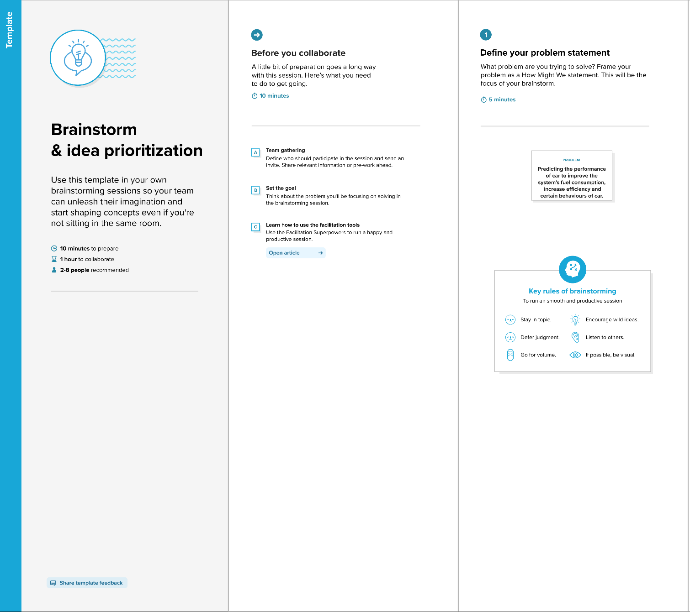

**Step-2: Brainstorm, Idea Listing and Grouping**

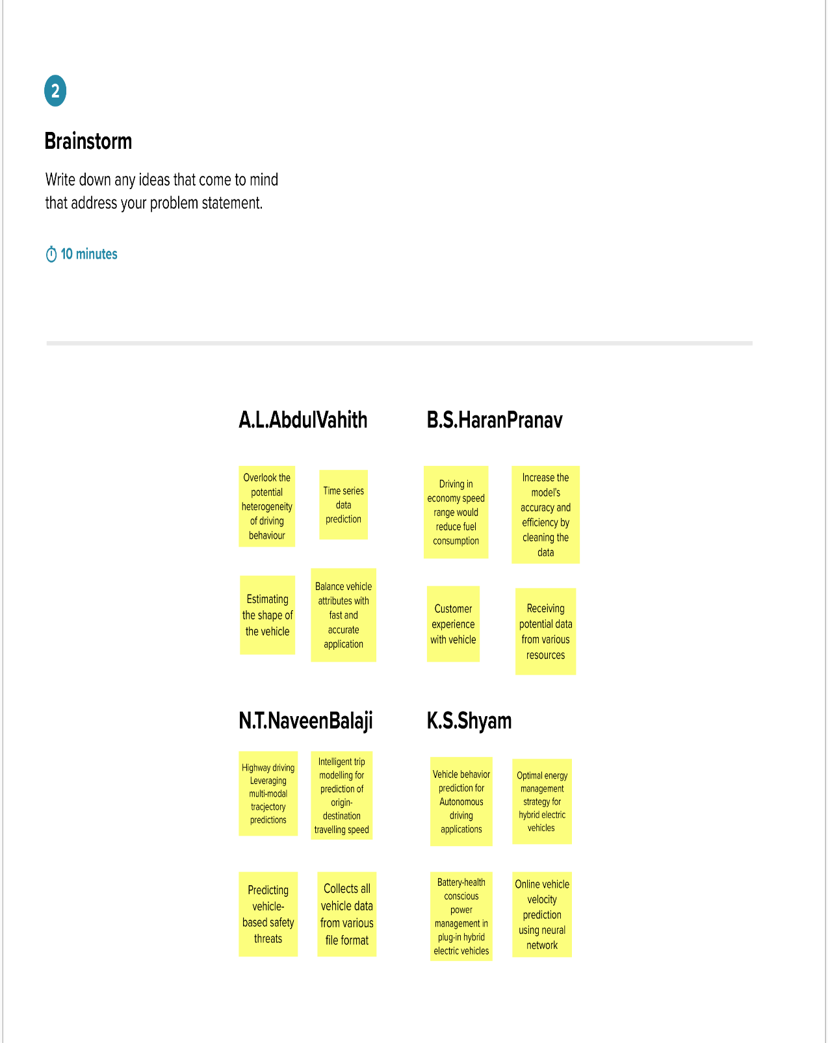

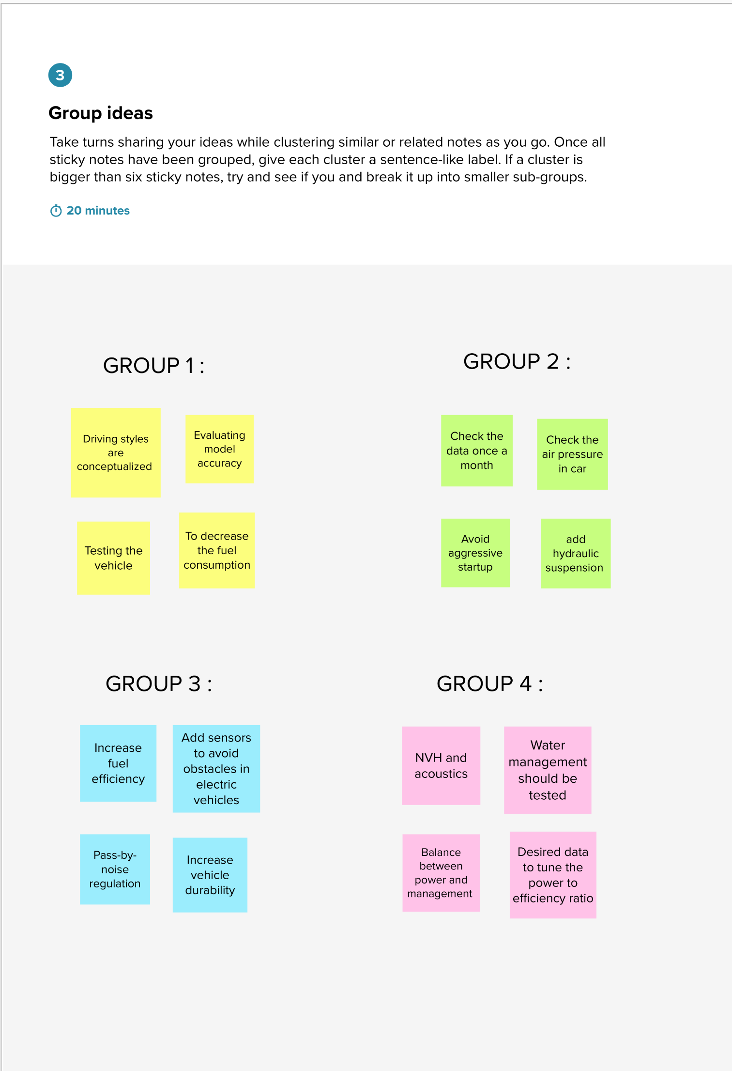 **Step-3: Idea Prioritization**

